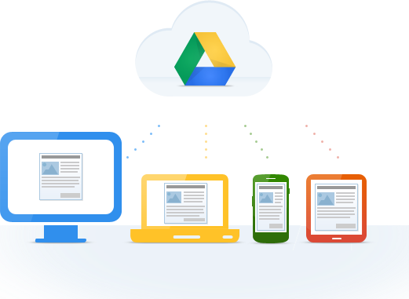
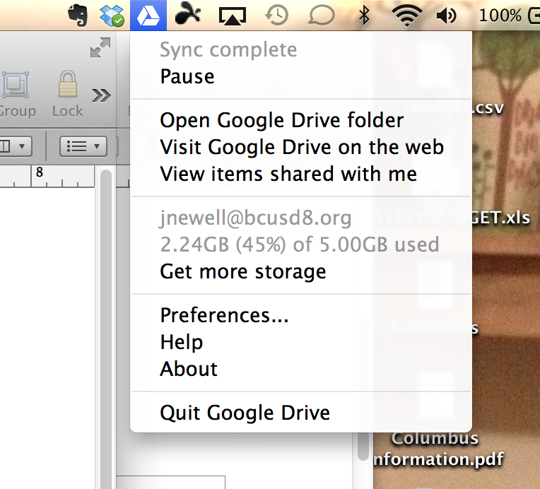
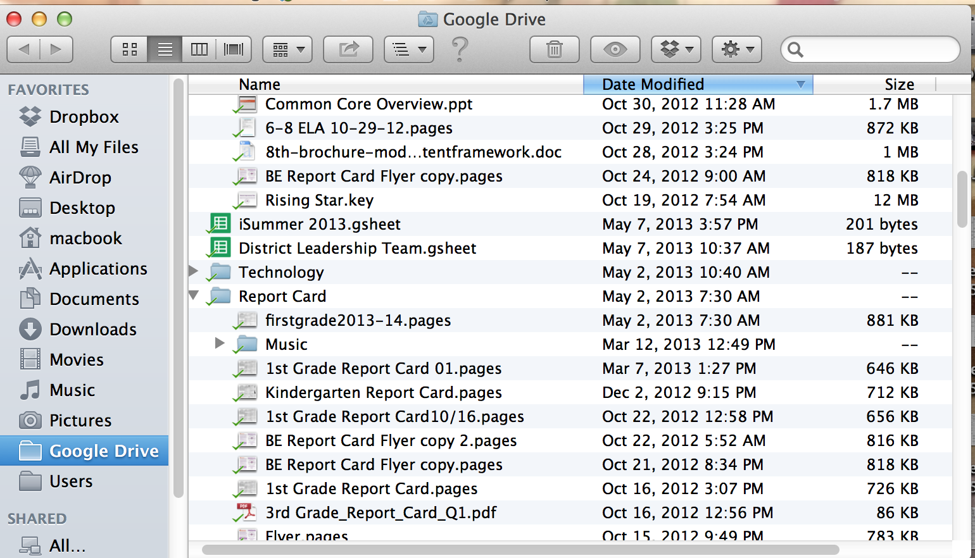
Google Drive
Google Drive Icon
This will open up the “Google Folder” that is stored on your hard drive. With syncing, Google will place a file on your hard drive and one in the Cloud.
Visit Google Drive on the web will allow you to view your documents from the internet. It will also allow you to create documents, presentations, and spreadsheets.
View items shared with me will allow you to see files that another user has shared with you.
Understanding the Interface
Open Google Drive Folder
This shows you what files are locally stored on your computer and in the cloud. I can add a file to the cloud by simply dragging and dropping it into the Google Drive Folder.
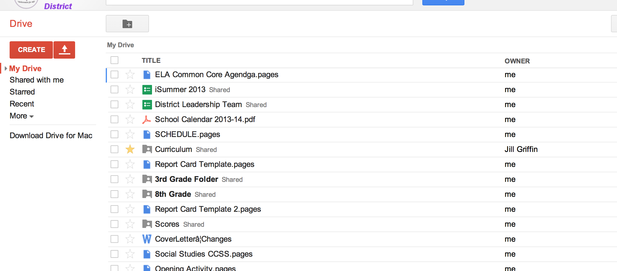
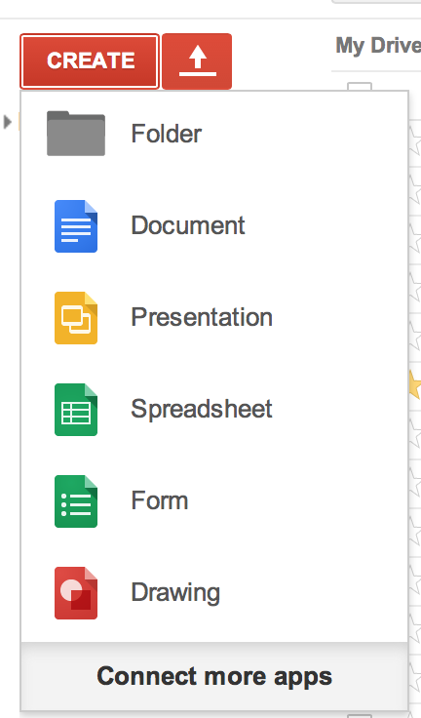
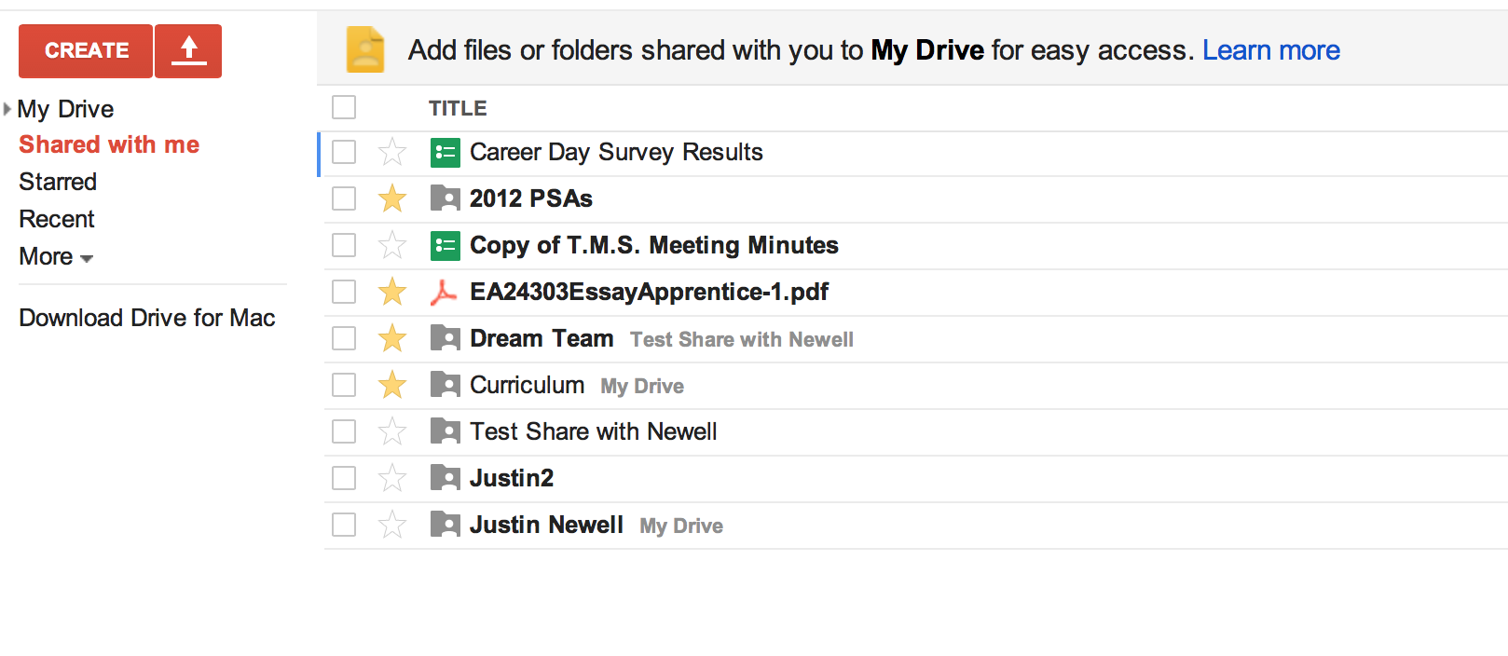
Visit Google Drive on the Web
All your documents and files that are stored on the web.
Click Create to make a new:
Document
Presentation
Spreadsheet
Form
Drawing
“Shared with me” shows the files that have been shared with you from another user.
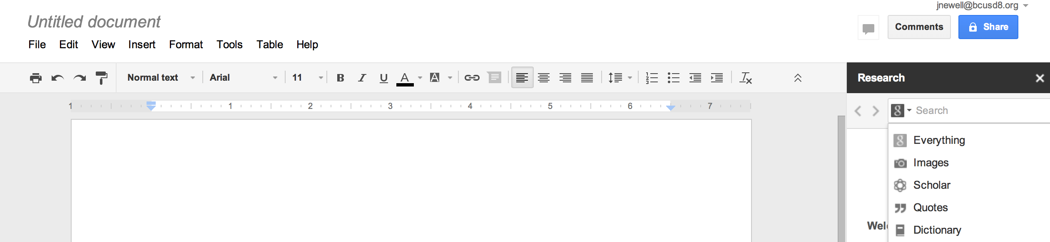
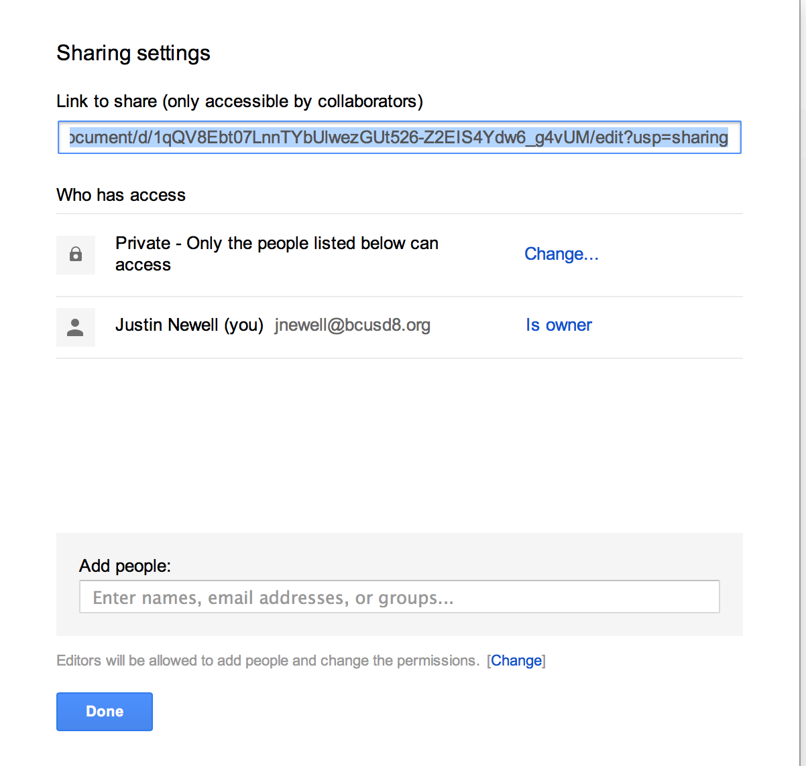
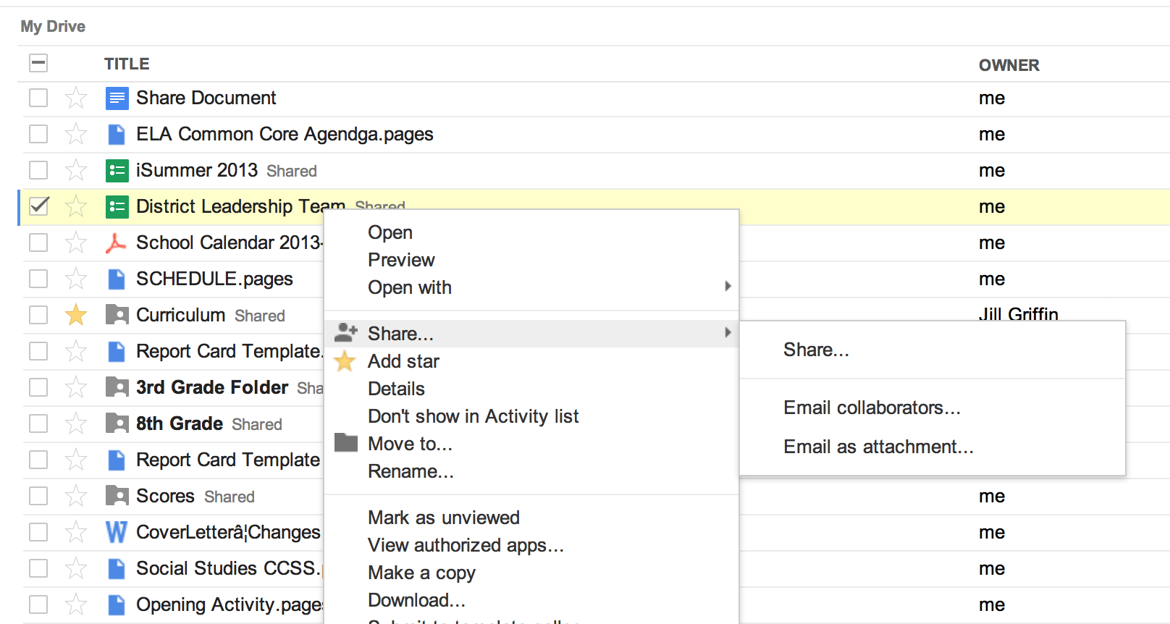
Sharing a Document
Open the document then click “Share”
Add people that you want to “Share” the file with.
Another way...
Do a Control + Click on the file in the home screen.

It will bring up a screen...where you can share...move the file...or download the file
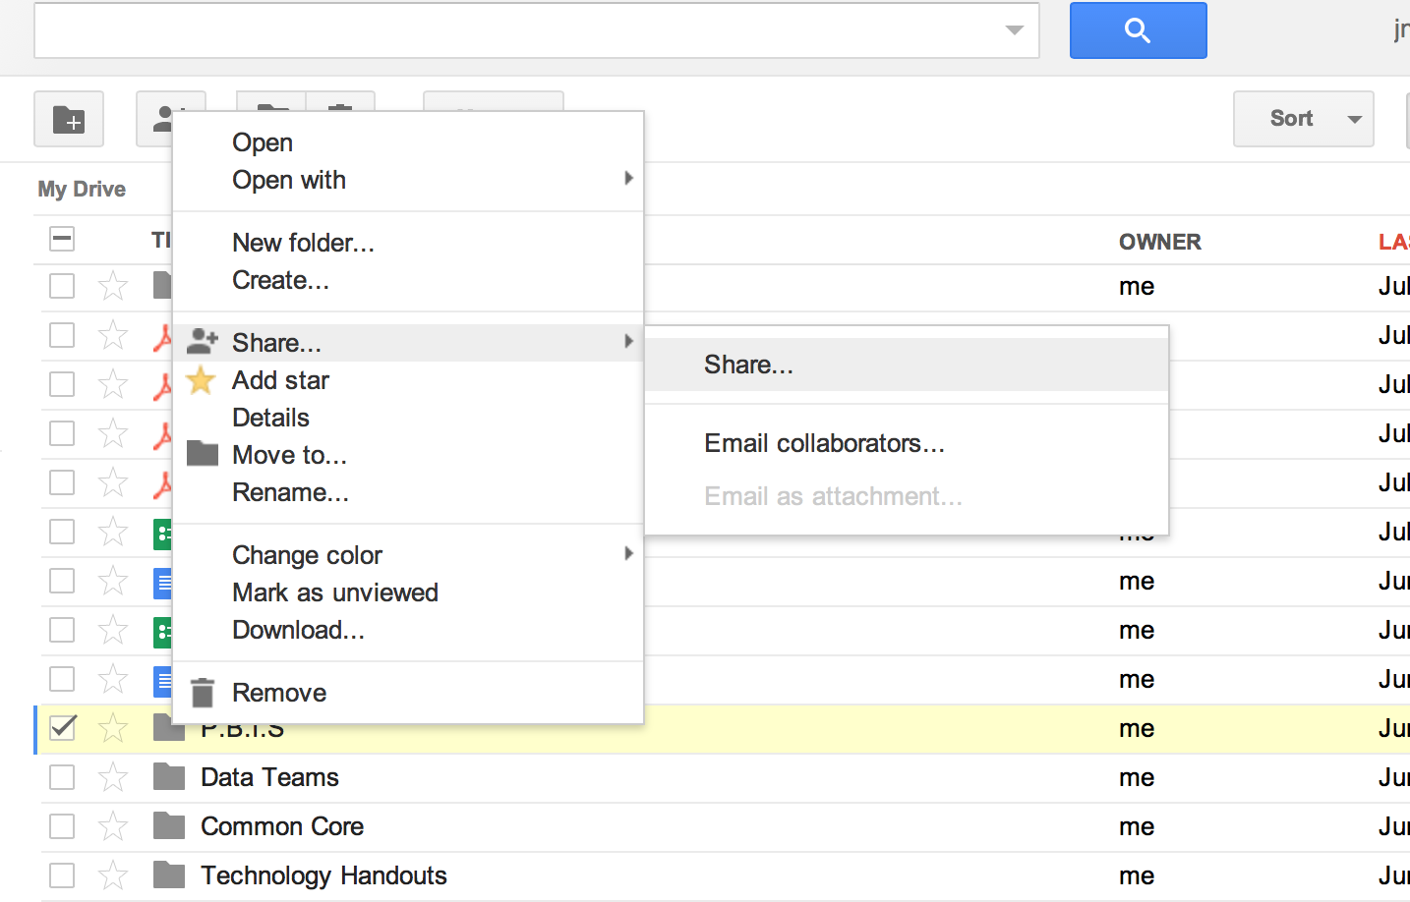
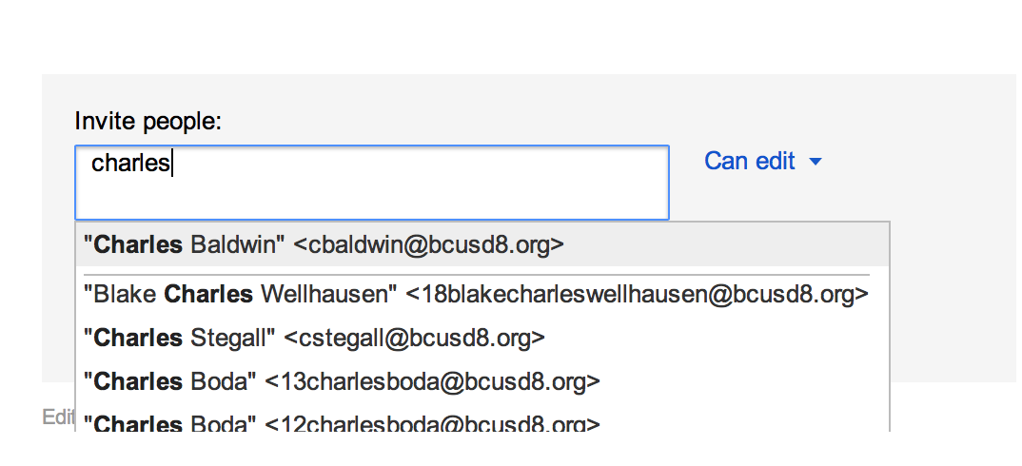
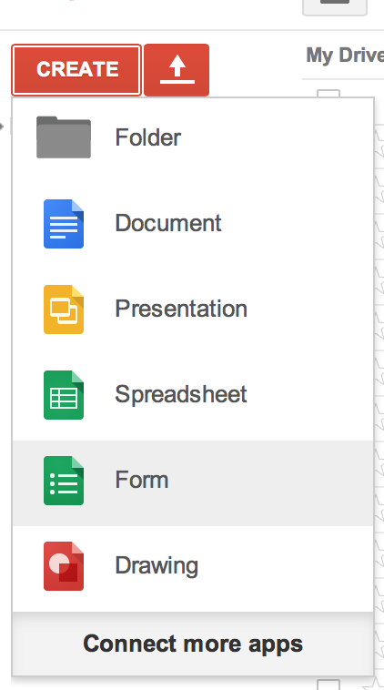
Sharing a Folder
Do a Control + Click on the file in the home screen.

It will bring up a screen...where you can share...move the file...or download the file
Type the name of the person to share the folder
Creating a Survey
Click “Create” then click “Form”
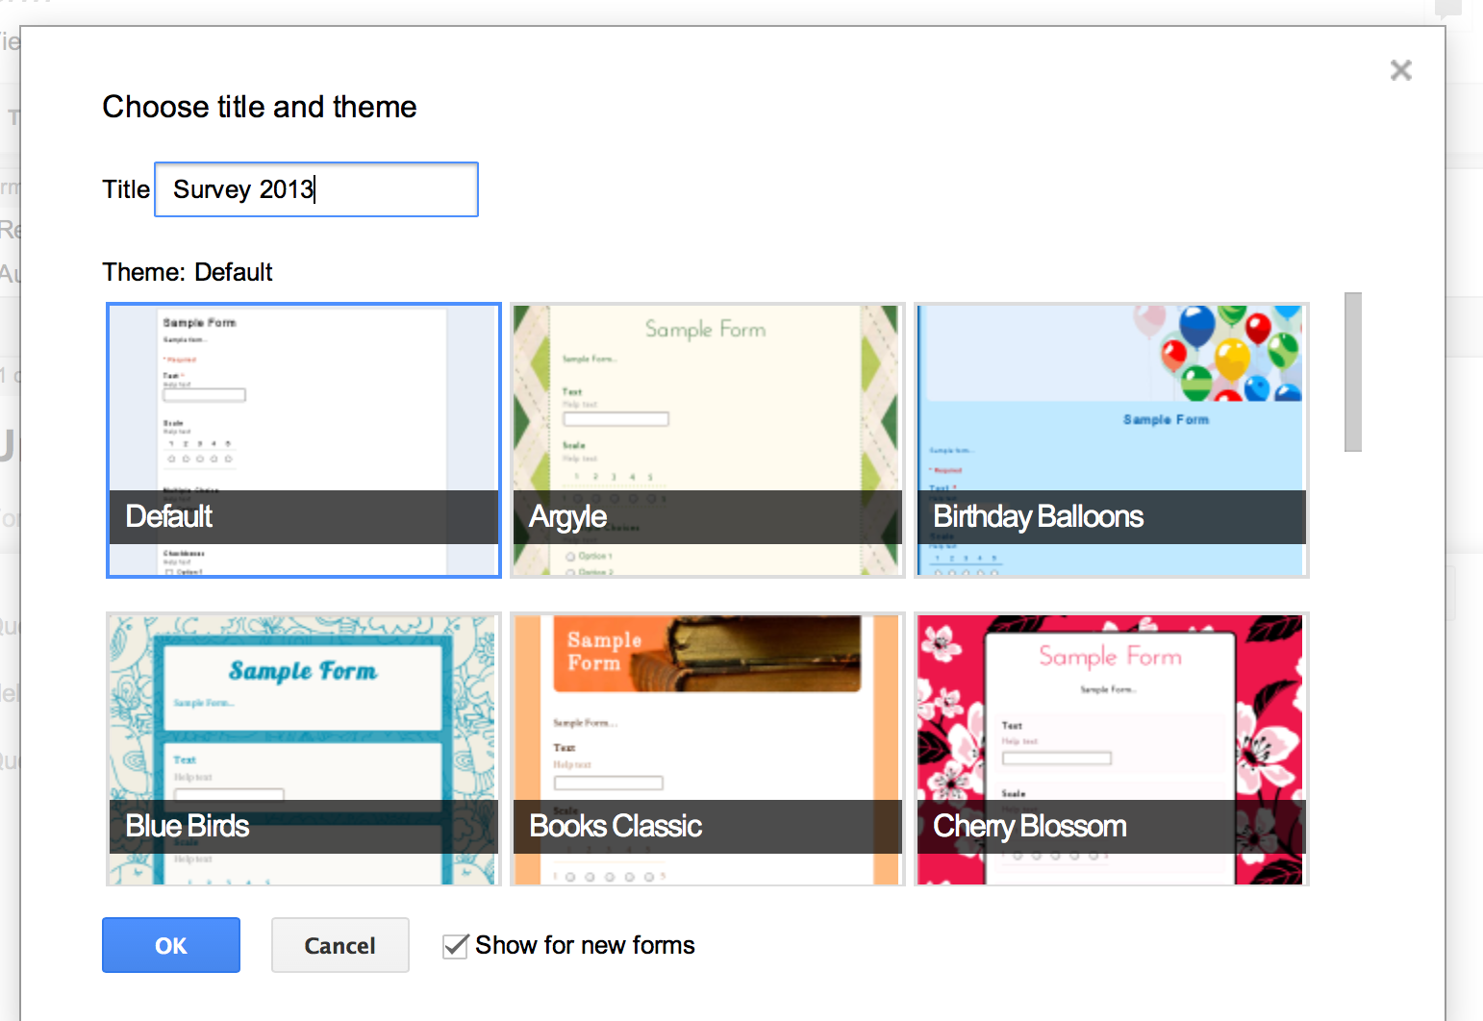
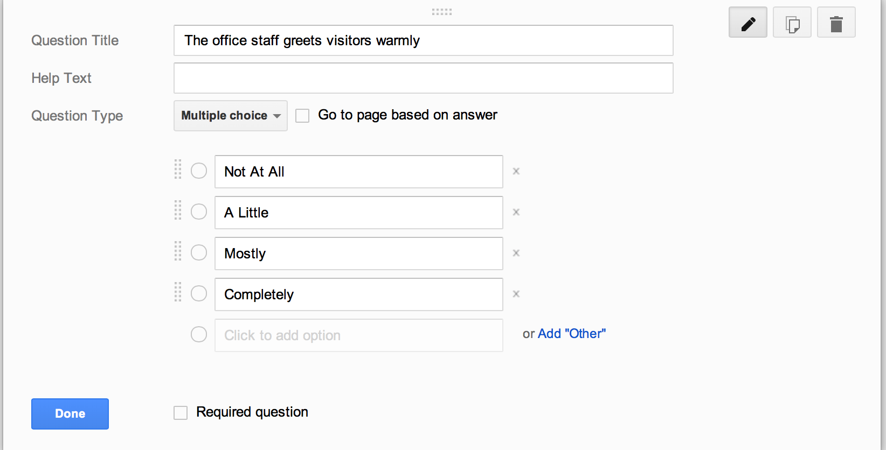
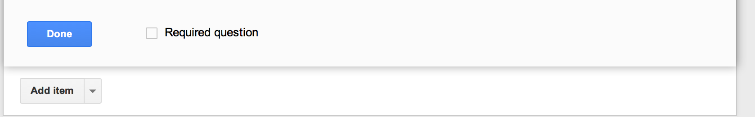
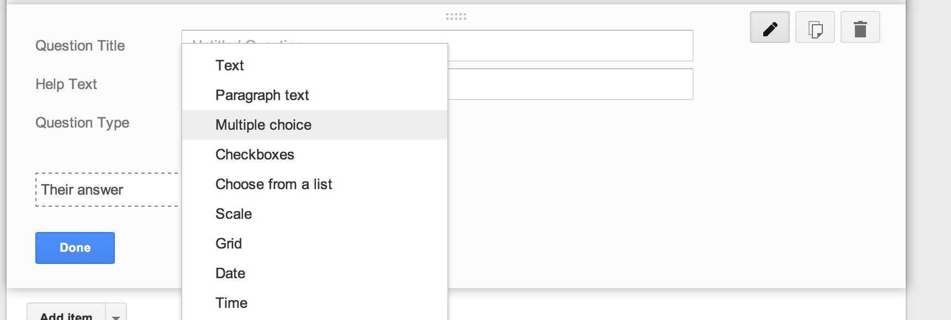
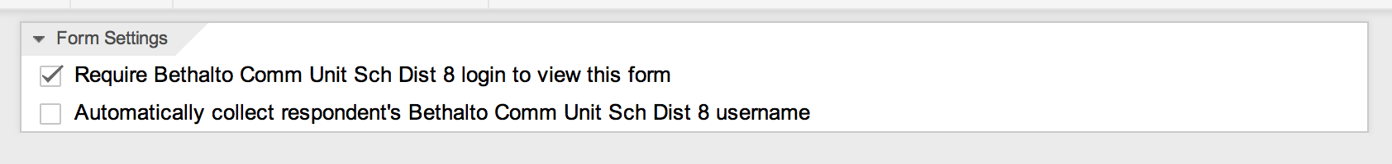
Give your survey a name

Select the theme

Click “OK”
Click “Form Description” to add directions for the survey.
Fill out the question
Fill out the choices
Click “Done” when finished with the question
Click “Add Item” to add an addition question
Click “Question Type” to change the expected response.
Remove the check mark to share with others.
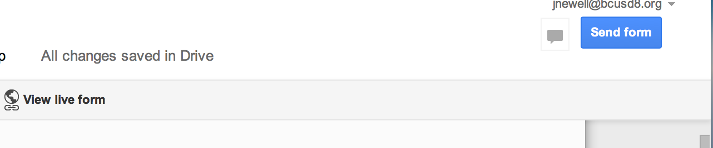
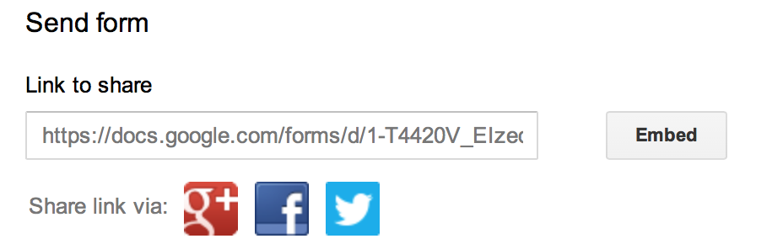
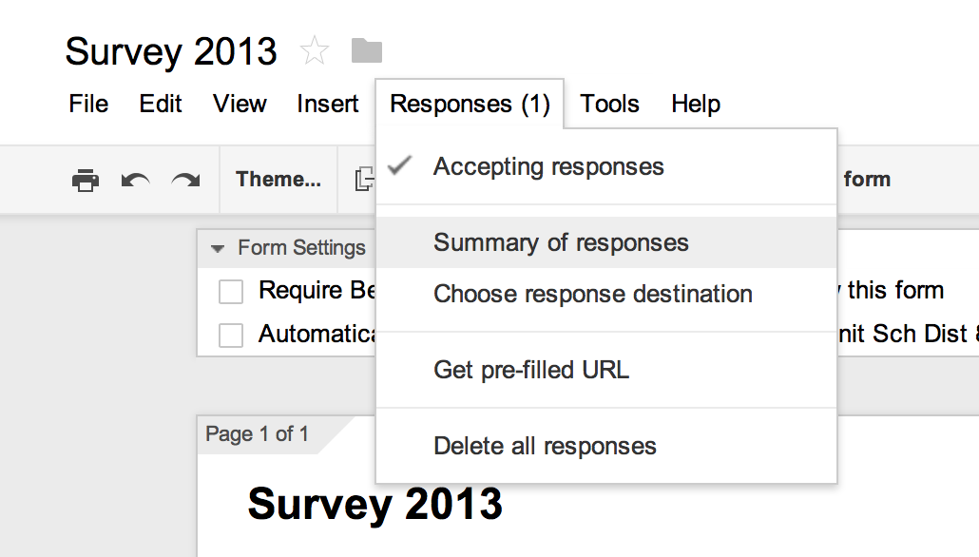
Click “View Live Form” to preview the survey.
Click send form when you are ready to disperse your survey.
Copy the link and send it out!
Click “Summary of Responses” to view the responses

